

Migrating from the Classic AMPL IDE
to Visual Studio Code
A Step-by-Step Guide for Current AMPL IDE Users
AMPL Optimization, Inc.
Prepared by the AMPL Technical Team

Overview
AMPL has ended development and support of the classic AMPL IDE. The immediate driver is Apple's removal of Rosetta, the compatibility layer that lets older Intel-built applications — including the AMPL IDE — run on Apple Silicon (M-series) Macs. Once Rosetta support ends, expected in the second half of 2027, the AMPL IDE will no longer run on new Apple Silicon devices.
Visual Studio Code (VS Code) with the official AMPL extension is the supported replacement. It's actively maintained, runs natively on every major platform, and — once configured — reproduces the same core workflow: file navigation, syntax-highlighted editing, and an AMPL command console. Moreover, it brings a lot more functionalities (e.g. running python code) to the same editor you use for your AMPL models.
Who this guide is for
This guide is written for existing AMPL IDE users migrating an established workflow to VS Code. If you're setting up AMPL in VS Code for the first time, with no prior AMPL IDE experience, see "Getting Started with AMPL in VS Code" instead.

Prerequisites
- A computer running macOS, Windows, or Linux, with an existing AMPL installation (license, solvers, and binaries already in place).
- Administrator rights to install software.
- Your existing AMPL project folder(s) — models, data files, and scripts — accessible on disk.

No AMPL configuration is lost in this migration — you're changing editors, not your license, solvers, or files.

How the Pieces Map Over
Before making any changes, it helps to know what each part of the AMPL IDE corresponds to in VS Code:
AMPL IDE | VS Code Equivalent | What it's for
File Navigation Pane | Explorer (activity bar) | Browse files, open/change your working folder
File Editing Pane | Editor area | View, edit, and save model/data files with syntax highlighting
AMPL Command Pane | AMPL Console (via Command Palette) | Run models, data files, and scripts; view output
N/A | Official AMPL Extension | Adds syntax highlighting, run/display commands, and the console

Part 1 — Install VS Code
Step 1. Download the installer
Go to the official VS Code download page and select the build for your operating system.
🔗 code.visualstudio.com/download
Step 2. Run the installer
macOS: open the .dmg and drag the VS Code icon into Applications.
Windows: run the downloaded .exe and follow the setup wizard.
Step 3. Launch VS Code and skip sign-in
An account is not required to use VS Code. When prompted, you can choose "Continue without signing in."
Step 4. Choose a color theme
Optional. A light theme is visually closer to the classic AMPL IDE; a dark theme works equally well and is a common preference.

Part 2 — Install and Configure the AMPL Extension
Step 5. Open the Extensions view
Click the Extensions icon in the activity bar on the left (the stacked-squares icon).
Step 6. Search for "AMPL" and install the official extension
Several AMPL-related extensions may appear in the marketplace. Install only the one published by AMPL Optimization — it's identifiable as the official listing with the most downloads.
Make sure you install the right extension
Unofficial, community-built AMPL extensions exist in the marketplace. Only the extension published by AMPL Optimization is supported and covered by this guide.
Step 7. If AMPL isn't detected, set the path manually
Open a terminal in VS Code (Terminal > New Terminal) and type ampl. If it opens an AMPL shell, no action is needed. If you see "command not found," locate your AMPL installation folder and paste that path into the binary path setting.
🔗 macOS: “/Applications/AMPL/ampl”
🔗 Windows: “C:\Users\<YourUsername>\AMPL”
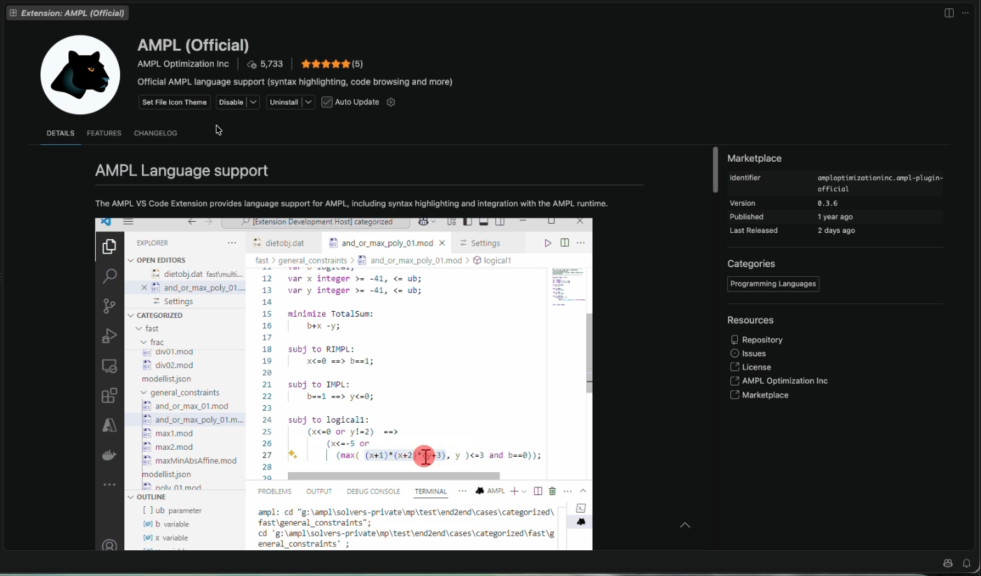

Part 3 — Recreate Your Workspace
Step 9. Open your working folder
In the Explorer view (top icon, activity bar), click "Open Folder" and select your existing AMPL project folder — the same one you used in the AMPL IDE. You can switch folders anytime via File > Open Folder.
Step 10. Trust the folder if prompted
VS Code may ask you to confirm you trust the folder's contents before it can run or create files. Click "Manage" then "Trust" to continue — this is a one-time step per folder.
Step 11. Confirm syntax highlighting is active
Open a .mod or .dat file. With the extension installed, AMPL syntax highlighting is applied automatically, along with inline actions for running files, displaying entities, and jumping to a variable's definition.
Step 12. Open the AMPL console
Press Command+Shift+P (macOS) or Ctrl+Shift+P (Windows) to open the Command Palette, type "AMPL," and select the command to open the console. This is the direct equivalent of the AMPL IDE's command pane, and also lists other AMPL commands (Solve, Run File, Reset) with their keyboard shortcuts.

Part 4 — Optional: Match the Classic Three-Pane Layout
By default, the AMPL console opens as a bottom panel. If you'd prefer a layout closer to the AMPL IDE — console in the center alongside the editor — you can redock it:
- Click and hold the console's tab and drag it into the main editor area.
- Release it over the shaded drop zone that appears under your open file to dock it there.
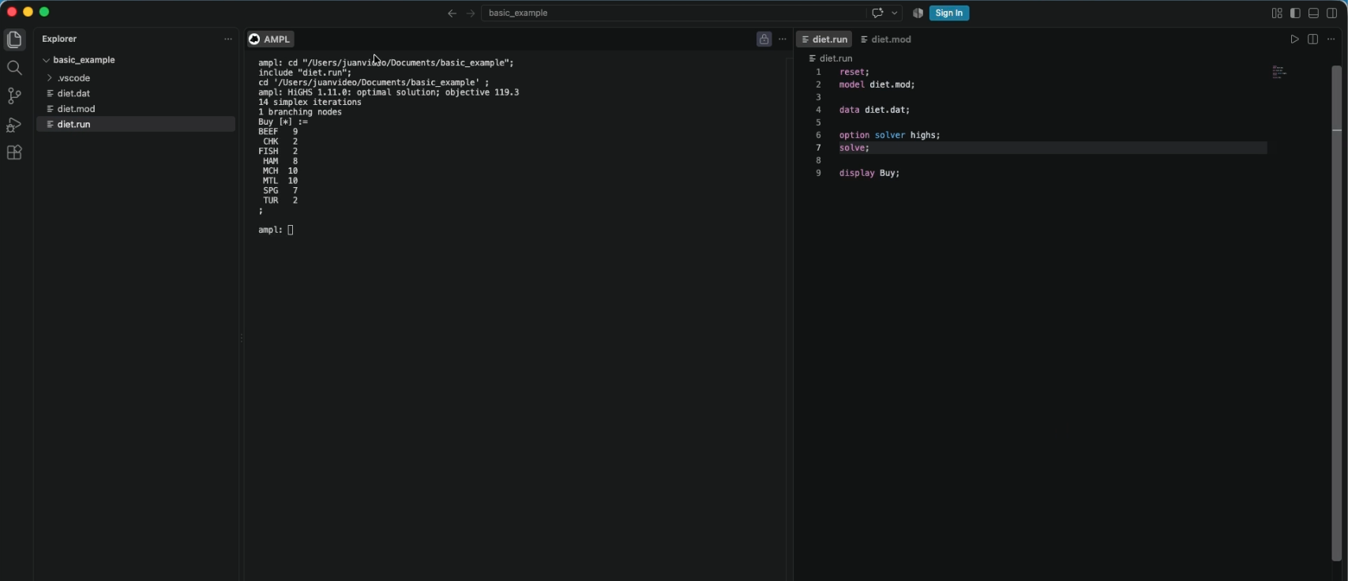

Day-to-Day Workflow
- Run a model, data file, or script directly from the editor, or via the console.
- Clear console output at any time with Command/Ctrl + K.

Troubleshooting
"ampl: command not found" in the terminal
AMPL isn't on your system PATH. Locate your AMPL installation folder and set it explicitly in the extension's binary path setting (see Part 2, Step 5).

No syntax highlighting or AMPL commands appear
Confirm the official AMPL extension (published by AMPL Optimization) is installed and enabled, and that the file has a recognized AMPL extension (.mod, .dat, .run).

VS Code won't let me run or save files in my folder
The folder likely hasn't been marked as trusted. Reopen it via File > Open Folder, and click "Manage" > "Trust" when prompted.

Additional Resources
- Video walkthrough of this migration
- "Getting Started with AMPL in VS Code" — for users new to both AMPL and VS Code
- Upcoming guide: converting pure AMPL scripts to Python

Questions? Reach out to support@ampl.com — we're happy to help.

