Getting Started with AMPL and amplpy in VS Code
Installation and first model, step by step

This guide walks you through setting up a complete AMPL development environment in Visual Studio Code using amplpy, the AMPL Python API. By the end you will have AMPL and a set of solvers installed as Python packages, your license activated, and a working model running from VS Code.
The workflow we recommend keeps your model in a .mod file and everything else (data, solver configuration, solving, results) in a Python script. Python acts as the orchestration layer, which makes it easy to connect your models to pandas, databases, dashboards, or any other part of your stack.

Step 1. Install Python
Download and install Python for your operating system from python.org/downloads. Any recent version (3.9 or later) works. If you are on Windows, make sure to check the option Add Python to PATH during installation so the python command is available from any terminal.
There are plenty of detailed installation guides online for each operating system, so we will not go deeper here. To confirm the installation worked, open a terminal and run:
python --version

Step 2. Install Visual Studio Code
Download VS Code from code.visualstudio.com and install it with the default options for your operating system.

Step 3. Get your license UUID
Your AMPL license is identified by a UUID that you will use to activate your installation. To find it, go to portal.ampl.com and sign in. Then navigate to My Licenses, click on your individual license, and copy the identifier shown there. Keep it at hand; you will need it in the next step.
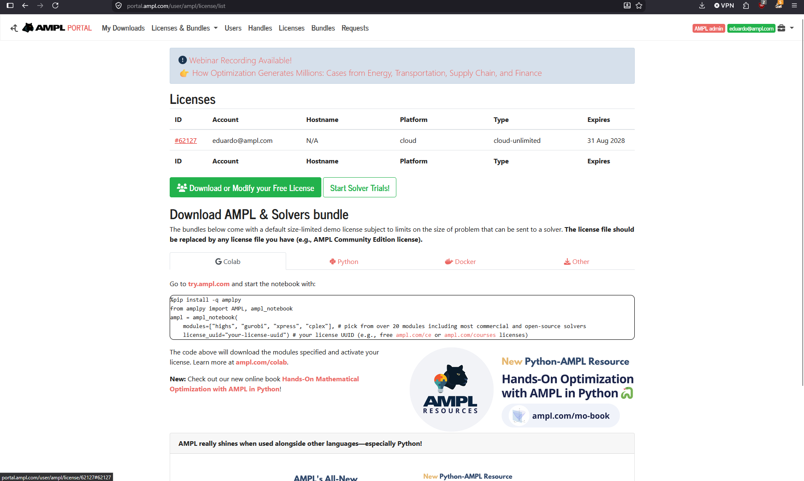
If you do not have a license yet, free options are available: the Community Edition at ampl.com/ce or, for students and instructors, ampl.com/academia.

Step 4. Install AMPL through amplpy
AMPL and all solvers are available as Python packages. Open a terminal and run the following commands:
# Install the Python API for AMPL:
python -m pip install amplpy --upgrade

# Install solver modules:
python -m amplpy.modules install highs gurobi xpress cplex

# Activate your license using the UUID from Step 3:
python -m amplpy.modules activate <your-license-uuid>
You can install only the solvers you need; the list above is just an example. To verify everything is in place, start Python and instantiate an AMPL object:
$ python
>>> from amplpy import AMPL
>>> ampl = AMPL()
If no error appears, AMPL is installed and ready.

Step 5. Set up VS Code extensions
Open VS Code and go to the Extensions view (Ctrl+Shift+X, or Cmd+Shift+X on macOS). Install the following two extensions:
- AMPL, the official AMPL extension, which provides syntax highlighting and language support for .mod files.
- Python (by Microsoft), which provides IntelliSense, debugging, and the ability to run Python scripts directly from the editor.
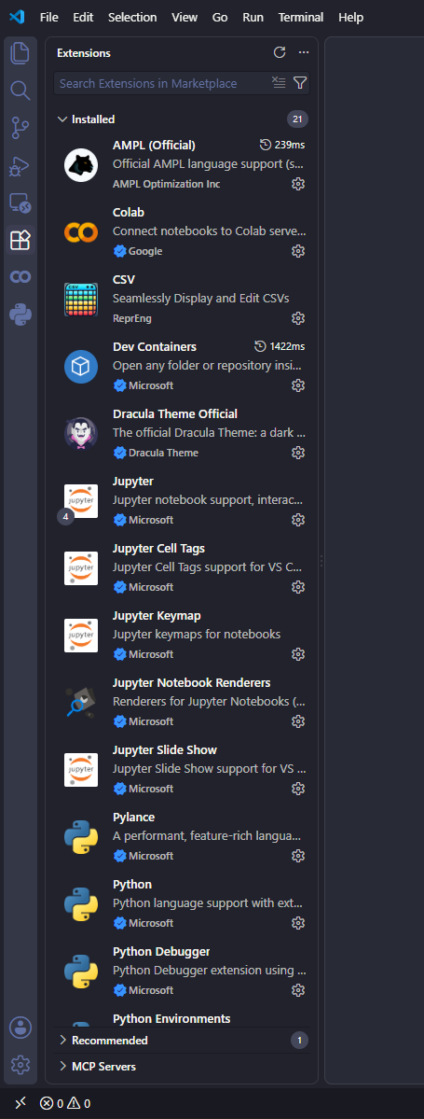
Step 6. Run your first model
Create a folder for your project and open it in VS Code (File > Open Folder). Inside it, create two files: a model file and a Python script. The model file contains only the model definition; the Python script loads the data, solves, and reads the results.

The model file: production.mod
set PRODUCTS;

param profit {PRODUCTS} > 0; # profit per unit
param hours {PRODUCTS} > 0; # production hours per unit
param avail >= 0; # total hours available

var Make {PRODUCTS} >= 0;

maximize Total_Profit:
sum {p in PRODUCTS} profit[p] * Make[p];

subject to Capacity:
sum {p in PRODUCTS} hours[p] * Make[p] <= avail;

The Python script: solve_production.py
import os
from amplpy import AMPL

ampl = AMPL()
ampl.cd(os.path.dirname(os.path.abspath(__file__)))
ampl.read("production.mod")

# Load data from Python
ampl.set["PRODUCTS"] = ["bands", "coils"]
ampl.param["profit"] = {"bands": 25, "coils": 30}
ampl.param["hours"] = {"bands": 0.005, "coils": 0.007}
ampl.param["avail"] = 40

# Choose a solver and solve
ampl.option["solver"] = "highs"
ampl.solve()
assert ampl.solve_result == "solved"

# Retrieve results
print(f"Total profit: {ampl.get_objective('Total_Profit').value():,.2f}")
print(ampl.get_variable("Make").get_values())
With solve_production.py open in the editor, press the Run button in the top right corner, or open a terminal in VS Code (Ctrl+`) and run:
python solve_production.py
You should see the HiGHS solve log followed by the total profit and the optimal production plan.

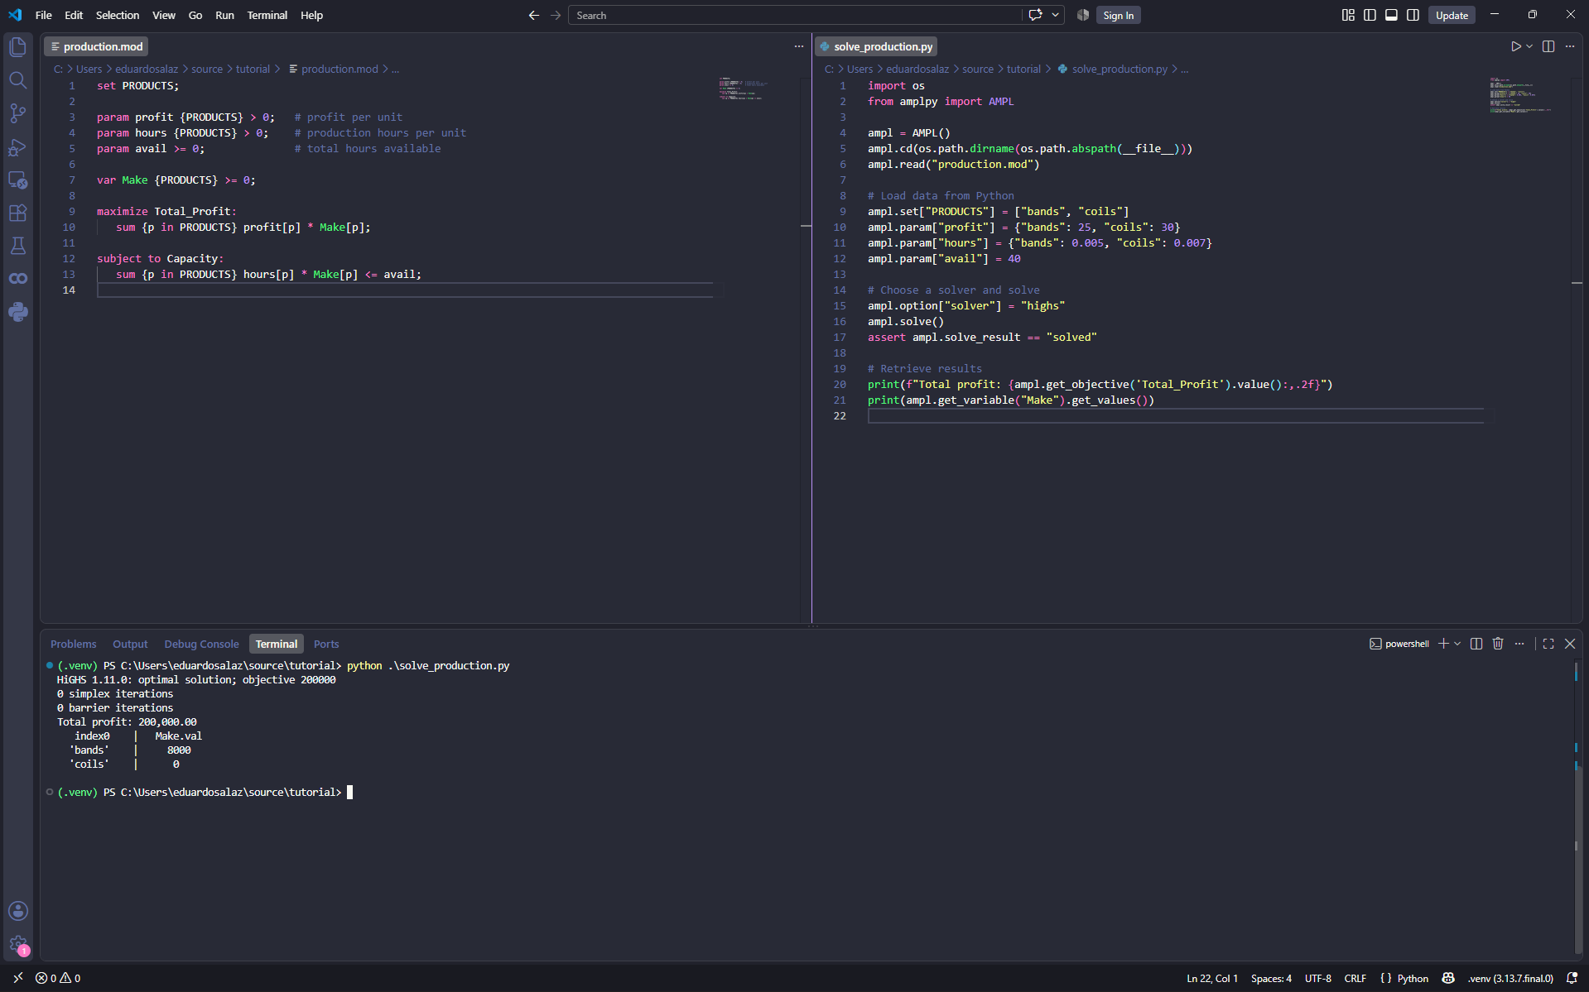

Next steps
From here you can load data directly from pandas DataFrames with ampl.set_data(), switch solvers by changing a single option, and pass solver-specific settings such as ampl.option["gurobi_options"] = "outlev=1". For solver options, modeling guides, and more examples, visit dev.ampl.com and the AMPL model colaboratory, where you can also try any of these examples in your browser.

